1. Create a Spring Boot Project with dependency 🡺 Spring Security.
2.   
   **NOTE**: See the below diagram for components.  
   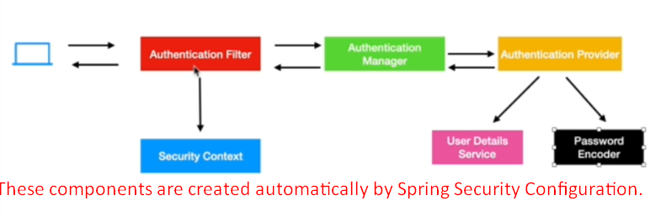
3. 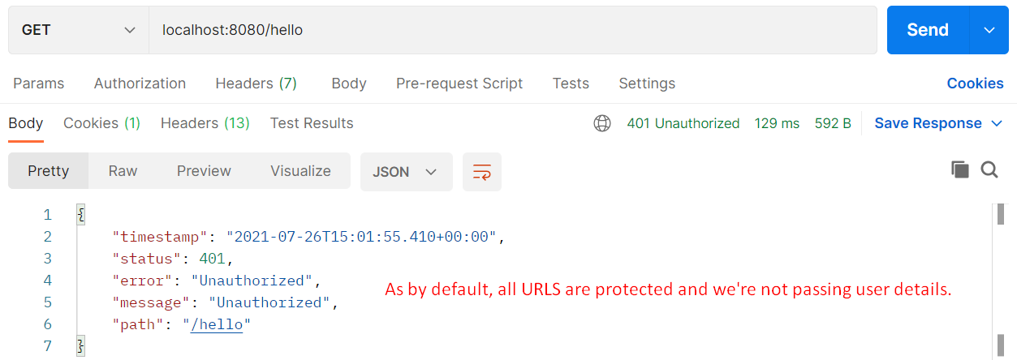
4. **Defaults**:
   1. **User Details Service Component:**
      1. A bean UserDetailsService is configured.
      2. To create a user with username=user and password would be displayed on the console when app is run.
      3. The password is UUID: Universal Unique Identifier.  
         This user details is stored in memory and gone in next execution.
   2. **PasswordEncoder**:
      1. Default Bean for Password Encoder is simple encoder which doesn’t encode the password.
      2. So the password displayed on the console is used directly and it is plain password.